How to use Labview from home using the Fresnel license:

If you are using a Windows OS:

1) Download the evaluation version of Labview here: https://www.ni.com/fr-fr/support/downloads/software-products/download.labview.html#306342
You will be asked to create a NI user account, it is free.
2) Download OpenVPN here: https://openvpn.net/community-downloads/
3) Contact Frederic Forestier to get an OpenVPN configuration file for your computer.
This will allow you to get your computer virtually located inside the Fresnel building.
4) Launch OpenVPN.
Import the configuration file
received from Frederic.
5) Click on “connect”. If the
is successful, the screen
should turn green

6) Launch Labview.
7) You are likely to be asked if you want to extend the trial version. Answer NO.
8) Go to: “Help -> Activate Labview Components” .
You will be asked if you want to start “NI license manager”, answer YES.

8) Go to “Network Licenses” panel and enter the address of the im2np server:
licence-labview.im2np.fr:27001
9) Restart Labview.
10) Labview will run as long as you stay connected to OpenVPN.

If you want to use Labview offline:
11) Download “lmborrow.exe” from the NI website:
https://knowledge.ni.com/KnowledgeArticleDetails?id=kA00Z000000P8vpSAC&l=fr-FR
And save it on your computer (in this demo case C:\Users\Mosaic\Labview_Offline)
12) Open a command windows (type “cmd.exe” in the search bar)
13) Navigate to the folder where “lmborrow.exe” is located. Use “cd” to change directory.
14) Type: lmborrow nilm dd-mmm-yyyy.
dd and yyyy are digits. mmm are letters (Jan, Feb, Mar …). To borrow the token until the
04th March 2020 23.59 PM, type 04-Mar-2020.
If successful, “Setting LM_BORROW=Current date:nilm:expiration date” is displayed.
15) Restart Labview. It is now running even if OpenVPN is stopped.
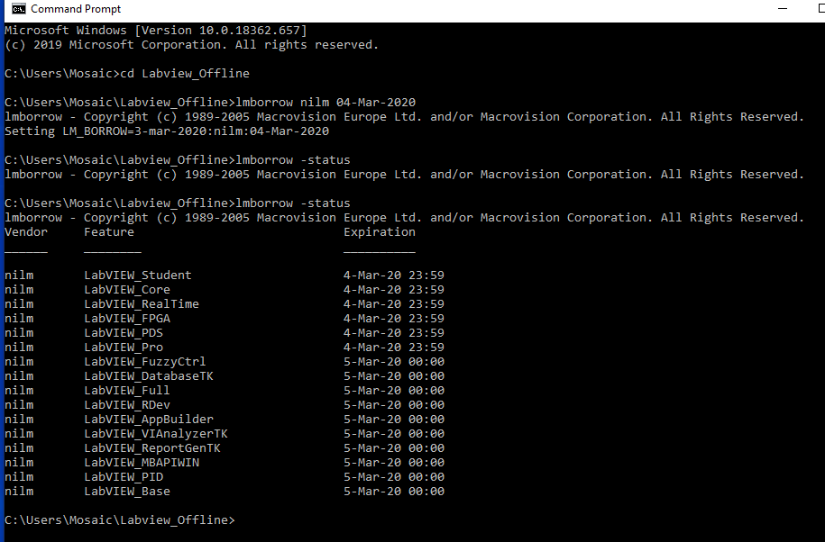
If you are using a Mac OS or Linux OS:
/!\ Labview is not specifically designed for these Operating Systems, therefore only a limited number of modules are available (https://www.ni.com/pdf/manuals/374717m.html)

1) Download the full version of Labview from the im2np server:
https://owncloud.im2np.fr/index.php/s/5PY5eKgfbJ875Mf
Both the Mac OS and Linux OS are included in the package.
2) Open the ISO file, go to the Labview folder and install the Labview package for your OS.
3) To install additional modules, go to the Labview Add-ons folder.
4) Once installed, Labview is automatically activated as “full version”, no need to do anything
else.

